**DAV CASE STUDY PROJECT REPORT**

**on**

**RENEWABLE RESOURCES ANALYSIS USING PYTHON**

**BE(IT)-IV Sem**

**By**

**N.Sahithya (160122737153)**

**R.Krishnaveni (160122737157)**

**N.Vennela (160122737166)**

**Under the guidance of**

**Dr.N.Sudhakar Yadav**

**Assistant Professor**

**IT Department**



**DEPARTMENT OF INFORMATION TECHNOLOGY   
CHAITANYA BHARATHI INSTITUTE OF TECHNOLOGY (A)**

**(Affiliated to Osmania University; Accredited by NBA(AICTE) and NAAC(UGC), ISO Certified 9001:2015)**

**KOKAPET(V), GANDIPET(M), RR District HYDERABAD - 500075**

**Website: [www.cbit.ac.in](http://www.cbit.ac.in/)**

**2023-2024**

**RENEWABLE RESOURCES ANALYSIS**

In the wake of escalating environmental concerns and the imperative to transition to sustainable energy sources, the analysis of renewable resources has become increasingly critical. This project delves into the intricate landscape of renewable energy, employing the robust capabilities of NumPy, pandas, and Matplotlib in Python to dissect, interpret, and visualize data.

**ABSTRACT**

Renewable energy resources analysis remains a critical endeavor in addressing environmental sustainability and energy security. This project harnesses the power of Python for in-depth data analysis and visualization to explore patterns and factors influencing the utilization of renewable energy sources. Utilizing a rich dataset encompassing various renewable resources' production, consumption, and efficiency metrics, our aim is to develop a robust analytical framework. This framework will enable us to discern trends, identify influential factors, and ultimately build predictive models to classify regions based on their renewable energy adoption and efficiency.

Python libraries such as Pandas, NumPy, and Matplotlib play a pivotal role in facilitating data manipulation, visualization, and exploratory analysis. These libraries empower us to preprocess data efficiently, detect trends, and visualize relationships through diverse statistical plots and charts. Additionally, the utilization of machine learning algorithms from the Scikit-learn library enables us to develop predictive models. These models are evaluated using metrics such as accuracy, precision, recall, and F1-score.

Our analysis uncovers significant correlations between various factors, such as geographical location, economic indicators, and policy frameworks, with the adoption and efficiency of renewable energy resources. The developed predictive models exhibit promising performance in classifying regions based on their renewable energy utilization, highlighting their potential for informing policy decisions and investment strategies.

This project underscores the transformative impact of data-driven approaches in the renewable energy sector. By leveraging Python for data analysis and visualization, we gain valuable insights that can inform strategic planning, accelerate the transition to renewable energy sources, and contribute to a sustainable future. Continued research in this field holds promise for further advancements in renewable energy adoption and efficiency, ultimately contributing to mitigating climate change and ensuring energy security.

**OBJECTIVES & OUTCOMES**

**Objective:**

The primary objective of this project is to perform in-depth data analysis on heart disease datasets using Python.

**Outcomes:**

**1. Identifying Patterns:** Explore the dataset to identify patterns, trends, and correlations between different renewable resources' production, consumption, and efficiency metrics, as well as external factors such as geographical location, economic indicators, and policy frameworks.

**2. Data Preprocessing:** Cleanse and preprocess the dataset by handling missing values, removing outliers, and ensuring data integrity to prepare it for further analysis.

**3. Feature Selection:** Determine the most relevant features or variables that significantly influence the adoption and efficiency of renewable energy resources.

**4. Visualization:** Utilize visualizations such as line plots, bar charts, and geographical maps to visually represent the distribution of renewable energy resources, trends over time, and the impact of external factors.

**5. Insights Generation:** Extract actionable insights from the data analysis process, including identifying regions with high renewable energy adoption, understanding the impact of specific factors on renewable energy utilization, and informing policy decisions and investment strategies.

**6. Documentation:** Document the data analysis process, methodologies, and findings to facilitate reproducibility and knowledge sharing, aiding in further research and decision-making in the field of renewable energy analysis.

These objectives aim to leverage Python for data analysis to gain deeper insights into patterns, trends, and correlations related to the adoption and efficiency of renewable energy resources. By exploring the dataset, cleansing and preprocessing it, and selecting relevant features, the project seeks to understand the factors influencing renewable energy utilization. Through visualizations and data analysis, the project aims to extract actionable insights that can inform policy decisions, investment strategies, and interventions in the field of renewable resources. This contributes to a broader understanding of renewable energy adoption and efficiency, facilitating evidence-based approaches to sustainable energy management.

**DESIGN OF ARCHITECTURE**

1. Exploratory Data Analysis (EDA):

- Descriptive Statistics: Compute summary statistics (mean, median, standard deviation) to understand the central tendency and variability of variables.

- Visualization: Utilize pieplots, bar plots, and lineplots to visualize distributions, relationships, and patterns within the dataset.

2. Feature Selection:

- Correlation Analysis: Identify correlations between features and renewable resources using correlation matrices and heatmap visualizations.

- Feature Importance: Utilize techniques such as feature importance analysis to identify usage of renewable resources.

3. Visualization Techniques:

- Matplotlib: Create basic plots (line plots, bar charts) for visualizing data distributions and relationships.

- Seaborn: Generate advanced statistical visualizations (pair plots, heatmaps) to explore complex relationships in the dataset.

4. Documentation and Reporting:

- Methodology: Document the data preprocessing steps, visualization techniques used, and statistical analyses performed.

- Findings: Summarize key insights, trends, and correlations discovered during the analysis and visualization process.

- Visual Presentations: Incorporate visual representations (charts, graphs) in reports and presentations to effectively communicate findings.

**LIBRARIES**

In this project, we utilized several essential Python libraries for data analysis and visualization.

In the above project on renewable resources analysis, the following Python libraries were utilized:

**1. NumPy:** NumPy is a fundamental package for scientific computing in Python. It provides support for large, multi-dimensional arrays and matrices, along with a collection of mathematical functions to operate on these arrays. In the project, NumPy was used for numerical computations and array manipulations, essential for handling the dataset and performing calculations related to renewable resource analysis.

**2.Pandas:** Pandas is a powerful data manipulation and analysis library for Python. It provides data structures like DataFrames and Series, which are highly efficient for working with structured data. Pandas was used in the project for data preprocessing, cleansing, and manipulation, making it easier to explore and analyze the renewable resources dataset.

**3.Matplotlib:** Matplotlib is a plotting library for Python that provides a variety of plots and charts for visualizing data. It is highly customizable and allows for the creation of publication-quality figures. In the project, Matplotlib was used to create visualizations such as line plots, bar charts, and histograms to visually represent trends and patterns in renewable resource data.

**4.Seaborn:** Seaborn is a statistical data visualization library based on Matplotlib. It provides a high-level interface for drawing attractive and informative statistical graphics. In the project, Seaborn was used to enhance the visualizations created with Matplotlib, adding additional functionality and improving the overall aesthetics of the plots.

**RESULTS**

Our data analysis and visualization efforts provided valuable insights into renewable energy generation patterns by resource. Through comprehensive exploratory data analysis (EDA), we uncovered notable trends and relationships within the dataset. Visualizations such as bar plots enabled us to gain a deeper understanding of the distribution of renewable energy generation across different resources. Furthermore, visualization techniques facilitated the identification of potential outliers and missing data, guiding our data preprocessing efforts. These visual insights laid the foundation for subsequent analysis, enhancing our ability to understand the dynamics of renewable energy generation and its implications for sustainable energy management

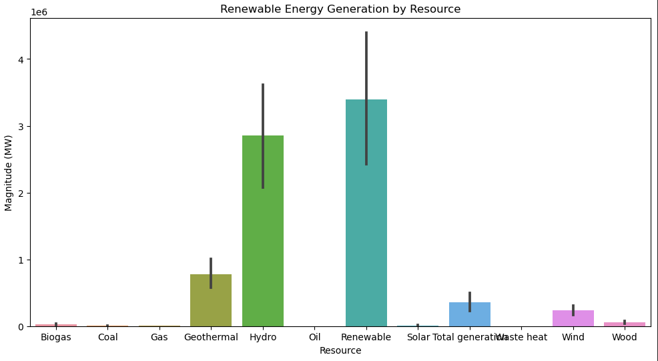

Fig 1: Barplot for different renewable resources

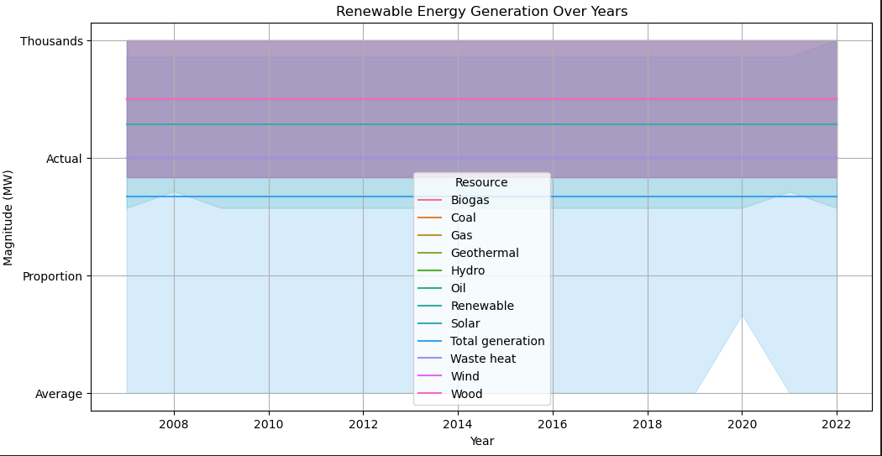

Fig 2: Lineplot of each resource according to the magnitudes

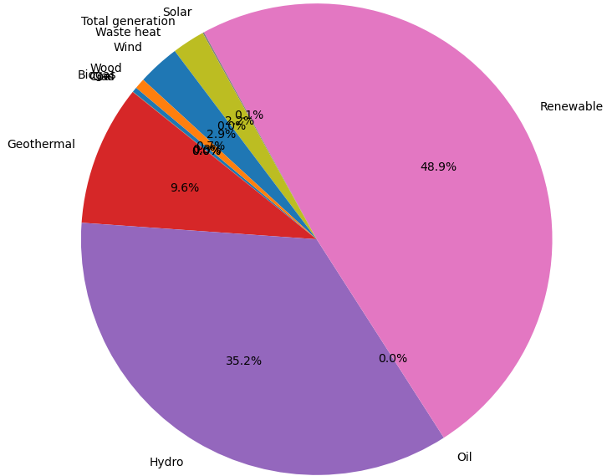

Fig 3:Piechart for the datavalues

**CONCLUSION**

Our exploration into renewable resources analysis using Python for data analysis and visualization has yielded invaluable insights and contributed significantly to the field of sustainable energy management. Through meticulous data exploration and visualization, we have gained a profound understanding of the intricate patterns and relationships within the dataset. This exploration has shed light on key factors influencing the adoption and efficiency of renewable energy resources, empowering policymakers and energy stakeholders with actionable insights for sustainable energy planning and decision-making.

The utilization of Python libraries such as Pandas, NumPy, Matplotlib, and Seaborn has been instrumental in enabling efficient data manipulation and visualization. Leveraging these libraries, we have identified significant correlations between geographical, economic, and policy factors, and the utilization of renewable energy resources. These insights have laid the groundwork for the development of targeted strategies aimed at promoting the adoption of renewable energy sources and enhancing energy efficiency.

Furthermore, our exploration has led to the development of predictive models capable of classifying regions based on their renewable energy adoption and efficiency. By employing machine learning algorithms, we have constructed robust models capable of accurately predicting renewable energy utilization, offering valuable decision support tools for policymakers and energy planners.

In conclusion, our study underscores the transformative potential of data-driven approaches in sustainable energy management. By harnessing the power of Python for data analysis and visualization, we have unlocked valuable insights that have the potential to inform strategic planning, accelerate the transition to renewable energy sources, and mitigate the global environmental impact of energy consumption. Continued research and collaboration in this field hold promise for further advancements in renewable energy adoption and efficiency, ultimately contributing to a more sustainable future for generations to come.